A Bank Guarantee letter can either be for a release or a drawdown, a release letter is in cases where we have been informed that the Bank Requires a release letter to provide the BANK GUARANTEE back to the tenant, in some circumstance the Original Bank Guarantee has been lost by Dexus or the Tennant/ Contractor
A Bank Guarantee Drawdown is where the tenant or contractor has failed to meet the requirements of their agreed upon terms therefor going into default requiring Dexus to drawdown on the funds as a way of obtaining owed money.
Note: Drawdowns made out to be partial, in this case you will need internal legal sing off.

Preparation
Create a New Document Execution form, this will assist you in completing the Bank Guarantee letter. Check in source that will do hold an original Bank Guarantee, if the location in source shows the location as ‘In safe” we do hold the BG (if unsure of how to create a DEF please see the instructions in the help centre)

First Steps
- In the Help centre, go into the Bank Guarantee Drawn Down/ Release Letters menu item – Click into the section, Once the word document open, click the attached template. this opens Ensure that you click enable content, (as shown below) this will open the template and allow you to type the details.

Filling out the details in the Template
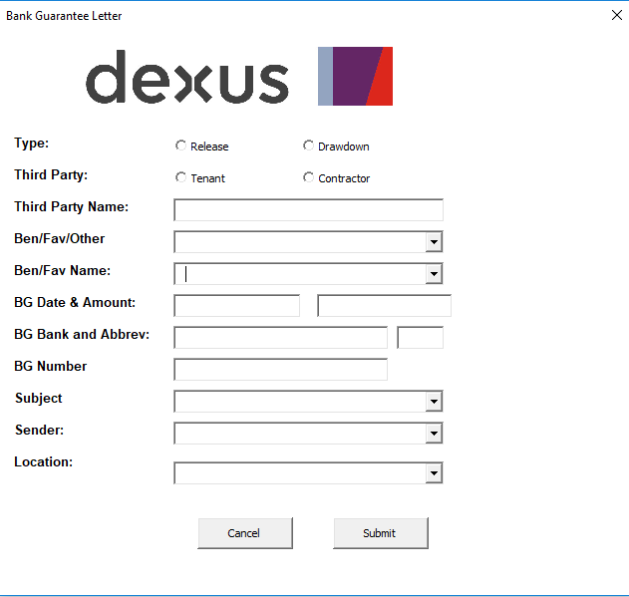

- Tick if it is a Release or Drawdown and if release is for Tenant or Contractor
- Third Party Name is the tenant or contractor, enter exactly as it is found on BANK GUARANTEE, without the ABN etc.
- Favouree Name is normally on document but can be also known as Beneficiary
- Fill out the BANK GUARANTEE date and amount
- BANK GUARANTEE Bank and Abbrev, example Westpac Banking Corporation is WBC
- The BG number is generally located on the Bank Guarantee
- Subject, is either Bank Guarantee or Bankers Undertaking, this needs to be manually types
- Location is always listed as ASQ Head office
- Sender is yourself or if you are providing this letter to another internal Dexus staff
- Click Submit

Filling out the details in the Letter

Special Considerations, interchangeable language. if the Bank Guarantee is called Bank Undertaking, this is changed in the letter and in the Subject line of the letter, as mentioned, you will need to type these words into the letter

See example of Generated Letter - Highlighted in Yellow is area that need to be checked or amended

Address: Shepparton Marketplace, 110 - 120 Benalla Road, Shepparton - This needs to appear as per our System, so when you create the DEF, that is how to address needs to appear
Tenant: Bsons Foods Pty Ltd (‘Customer’) – Ensure this is as it appears on the BANK GUARANTEE
14 February 2020

We refer to the Bank Undertaking dated 12th December 2017 No GC KornV2HYsN issued at the request of the Customer in favour of Dexus Wholesale Property Limited (DWPL) (‘Favouree’) in the amount of $21,549.21 by Westpac Banking Corporation (‘WBC’).

We advise that the Customer has defaulted under the terms of their Lease, accordingly, the Favouree demands that pay the sum of $21,549.21 in the form of a bank cheque made out in the Favouree’s name.

SIGNED for and on behalf of Dexus Wholesale Property Limited (ABN: 47 006 036 442) in its capacity as Trustee for the DWPF Shepparton Trust by its duly authorised attorneys under power of attorney Dated 01 September 2015 in the presence of: |  | ___________________  Signature of Attorney  __________________  Name of Attorney
___________________  Signature of Witness  ______________  Name of Witness |  | ___________________  Signature of Attorney  ________________  Name of Attorney

